Pushing and popping in a queue

#include<iostream.h>

#include<conio.h>

#include<stdlib.h>

class stack

{

public:

int queue[10],front,rear,ele;

stack()

{

rear=-1;

front=-1;

}

void push()

{

if(rear==9)

{

cout<<"\nqueue overflow";

}

else

{

front=0;

cout<<"\nenter element :";

cin>>ele;

queue[++rear]=ele;

}

}

void pop()

{

if(front==-1||front>rear)

{

cout<<"\nqueue underflow";

}

else

{

cout<<"\nelement deleted:"<<queue[front++] ;

}

}

void display()

{

if(front==-1)

{

cout<<"\nqueue is empty";

}

else{

for(int i=front;i<=rear;i++)

{

cout<<queue[i]<<"<-";

}

}

}

};

void main()

{

clrscr();

stack ob;

int ch;

char ch1,ch2;

do

{

cout<<"\n 1 push";

cout<<"\n 2 pop";

cout<<"\n 3 display";

cout<<"\n 4 exit";

cout<<"\nenter choice:";

cin>>ch;

switch(ch)

{

case 1:

ob.push();

break;

case 2: ob.pop();

break;

case 3: ob.display();

break;

case 4: exit(0);

break;

default:cout<<"\nwrong choice";

}

cout<<"\nwant to go to menu:";

cin>>ch2;

clrscr();

}while(ch2=='Y'||ch2=='y');

getch();

}

Outputs

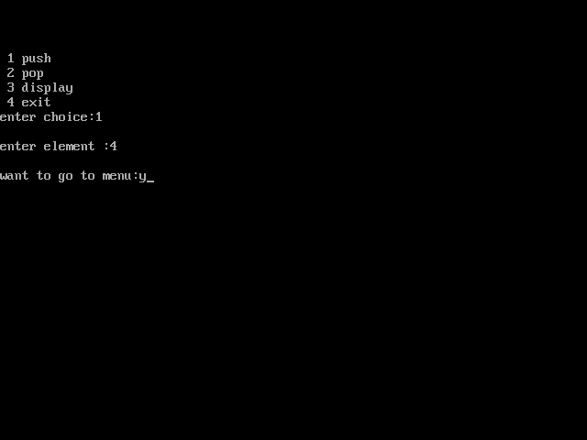

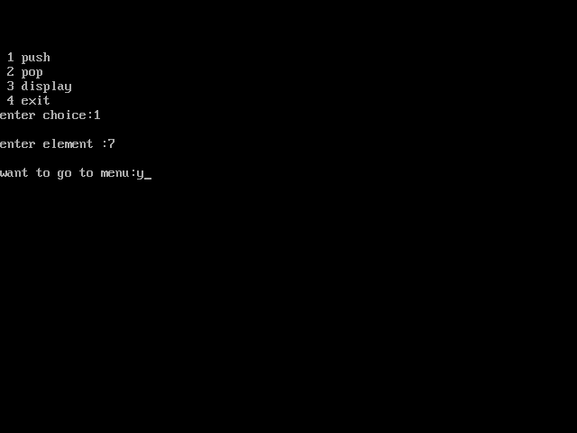

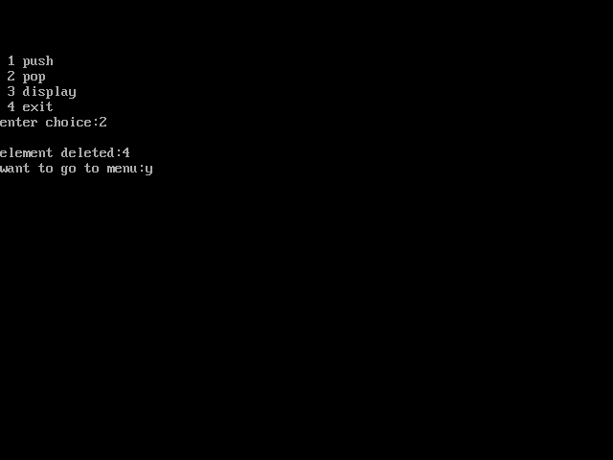

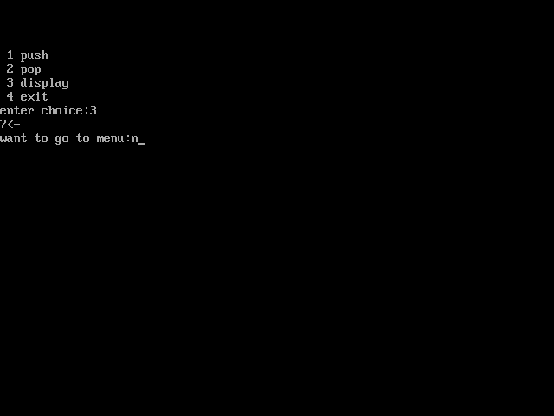

Pushing and popping in stack array

#include<iostream.h>

#include<conio.h>

#include<stdlib.h>

class stack

{

public:

int stack[10],top,ele;

stack()

{

top=-1;

}

void push()

{

cout<<"\nenter element :";

cin>>ele;

stack[++top]=ele;

}

void pop()

{

if(top==-1)

{

cout<<"\nstack is empty";

}

else

{

cout<<stack[top--] ;

}

}

void display()

{

if(top==-1)

{

cout<<"\nstack is empty";

}

else{

for(int i=top;i>=0;i--)

{

cout<<stack[i]<<"<-";

}

}

}

};

void main()

{

clrscr();

stack ob;

int ch;

char ch1,ch2;

do

{

cout<<"\n 1 push";

cout<<"\n 2 pop";

cout<<"\n 3 display";

cout<<"\n 4 exit";

cout<<"\nenter choice:";

cin>>ch;

switch(ch)

{

case 1:

ob.push();

break;

case 2: ob.pop();

break;

case 3: ob.display();

break;

case 4: exit(0);

break;

default:cout<<"\nwrong choice";

}

cout<<"\nwant to go to menu:";

cin>>ch2;

clrscr();

}while(ch2=='Y'||ch2=='y');

getch();

}

Outputs







